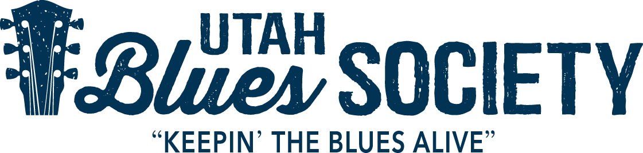

2019 UBF Sponsor Information

The 5th Annual Utah Blues Festival (UBF) is the signature event for the non-profit Utah Blues Society (UBS). For our 5th anniversary we will expand to a 1.5 day Blues Festival! It will be held Friday June 14th from 5pm – 10pm and Saturday June 15th from Noon – 10pm at the Gallivan Center in downtown Salt Lake City. This is the only festival in Utah dedicated solely to the celebration of blues heritage and its music. Blues music uses the human experience as its voice and is a uniquely American art form. The festival showcases local/national blues artists, free workshops, and a Youth Blues Band for the people of Utah.

Festival Location: The John T. Gallivan Center is a newly renovated outdoor amphitheater located at 239 S. Main Street, in the heart of downtown Salt Lake City. It features an expanded grassy amphitheater with a large tent on one side to provide shade in the summer. It’s a family friendly location with plenty of parking and public transportation options, (bikes, UTA & TRAX), to make the event easily accessible. The venue has a gorgeous two-story copper finished building that overlooks the main stage. It will serve as the site for the festival’s Sponsor and VIP Blues Club Patio.

Festival Overview:

Details: The festival runs from 5pm – 10pm on Friday and Noon to 10pm on Saturday. There will be high-quality Food Trucks, beer, wine, soda and water available. This is a family friendly event and kids under 12, as always, are free. This year will feature a special program for young blues lovers. We will have Free workshops throughout the day, on Saturday June 15th , in the Marriott City Center, our workshop sponsor. This year will feature the popular harmonica workshop and a couple new workshops to celebrate our 5th anniversary. Look to our website for updates.
There will be craft/arts and non-profit vendors throughout the day for you to enjoy. There is plenty of seating and room for blankets on the grass.

Artists: This year’s festival line-up features Jason Ricci & The Bad Kind, Sue Foley and Tab Benoit on Friday night, June 14th. On Saturday June 15th we will start, as always, with the Utah Blues Society sponsored Blues Youth Showcase, followed by Backtrack Blues Band, Café R&B, Welch Ledbetter Connection, Mindi Abair & The Boneshakers and Ronnie Earl & The Broadcasters. This is a line-up worthy of our 5th anniversary and is attracting blues fans from across the country.

Blues Youth Showcase: Each year the UBS sponsor’s a Blues Youth Showcase band that opens the Festival. Our commitment to kids is ongoing within the community and keeping blues alive!

Workshops: Once again, the UBS will host free workshops during the festival for children and adults. A blues harp (free high quality blues harps provided to the first 125 people) workshop will be held in a ballroom in the adjacent Marriott City Center Hotel. This year will also feature a couple NEW free workshops for our patrons to attend. Details to be announced.

About the Utah Blues Society: The Utah Blues Society is a 501(c)(3) nonprofit corporation with a mission to preserve Blues heritage, celebrate Blues recording and performance, expand statewide awareness of the Blues and ensure the future of this uniquely American art form. The Utah Blues Society is one of over 200 affiliates (national and international) of the National Blues Foundation based in Memphis, Tennessee.

The festival depends on support from individuals and businesses within the community to insure its continued success. We hope you will consider this opportunity to sustain our mission and generate exposure for you or your organization. The Utah Blues Festival is our main fundraising event. The money raised supports our programs throughout the year. They include:

• Blues in the Schools – We sponsor local and national artists/educators to engage school aged kids in customizable, (workshops, assemblies, etc.), in a multidisciplinary, (social studies. music, literature) hands-on approach to teach them about the importance of blues heritage/music in American history. We have worked with many kids, from many schools and some of them will be at the festival to answer questions and tell you about their own experiences with the program.
• Youth Blues Scholarship Program – provides scholarships for qualified young artists, in the instrument of their choice, to attend Blues music/performance camps.
• Musician Assistance Fund – Provides financial assistance to Blues artists/families with medical and life altering events/emergencies.
• Exposure - Helps send Utah Blues artists to the International Blues Challenge (IBCs) held in Memphis, TN each January.

We anticipate 3,500+ attendees, representing a diverse demographic from throughout the community/region/nation. Sponsor support will be recognized in various ways: the festival website, social media, radio spots, print ads and posters, venue banners, t-shirts, and stage shout-outs. Sponsor support is critical and can be provided as in-kind and/or cash donations. Talk to us about how you would like your sponsorship to work for you!!

2019 Utah Blues Festival Sponsor Opportunities:

These are the sponsorships levels available and are fully tax-deductible per IRS regulations. Utah Blues Society Tax ID # 46-5673826 SPO

SPONSORHIP OPPORTUNITIES
2019 UTAH BLUES FESTIVAL
TITLE SPONSOR | $5,000
PLATINUM | $2,500
GOLD | $1,500
SILVER | $1,000
BRONZE | $500

Sponsors and Blues Club/VIP members will have exclusive access to the top floor and covered patio of the two-story building overlooking the stage. It’s a great place to relax, get out of the heat and mix with clients or guests. Sponsors will also have access to limited reserved seating directly in front of the stage.
Additional benefits - quantity based upon level of sponsorship
• Blues Club/VIP & General Admission tickets to the festival
• Access to the Blues Club/VIP Patio (includes 3 beer or wine tickets per day, unlimited soda, water, and excellent food (dinner Friday & lunch/dinner on Saturday), air conditioned/shaded seating in the Hall and padded seating right in front of the stage.
• Access to all workshops
• Vendor space ~ if interested (10 x 10 – tent not provided)
• Commemorative Sponsor Poster

Please contact Tripp Hopkins at hopkinso@comcast.net or 801-989-4280 if you are interested in becoming/continuing to be a sponsor of the Utah Blues Festival.

